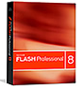
Macromedia Flash Resources

Tutorials

http://www.flashkit.com/tutorials/

http://www.echoecho.com/flash.htm

http://www.kirupa.com/developer/mx2004/index.htm

http://www.w3schools.com/flash/default.asp

